Seeds For Thought

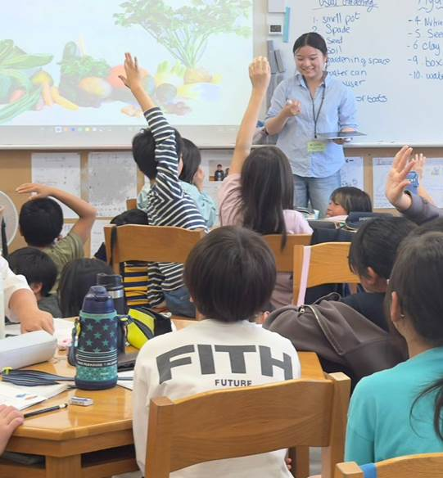
Seeds for Thought is a student-led enterprise operating under Enactus Southampton. We tackle food literacy across all age groups by delivering educational content designed to create long-term behavioural change. We aim to help people lead healthier lives through a better understanding of what’s in their food, what they should be eating and how to lead a more sustainable lifestyle. As part of our student enterprise, we sell hydroponic kits and are developing aeroponic kits; these products support our mission by making growing fresh produce accessible at home and in classrooms. Our goal is to create both commercial and social impact, using revenue from sales to sustain and scale our educational programmes.
The Seeds for Thought Educational Programme delivers engaging sessions that combine nutrition, hydroponics and sustainability. The initiative promotes awareness of healthy eating habits and a balanced diet while introducing participants to innovative, soil-free plant-growing techniques. All of our education sessions are provided free of charge to schools and community groups. We also participate in events such as the New Forest Roadshow and the Science and Engineering Festival each year spreading awareness about sustainability through the use of science.
Our educational offer includes a five-week programme for schools as well as one-time sessions designed to fit different schedules and learning needs. Sessions typically last 45, 60 or 90 minutes, allowing flexibility for teachers and community organisers. Each session blends theory with interactive activities and games so participants understand and remember key concepts in a fun and practical way. We are also happy to adapt our sessions to meet the specific needs or goals of each school or community group, ensuring that every experience is relevant, engaging and accessible.
Building on last year’s success, when we reached over 90 primary school children and received exceptionally positive feedback, the programme has expanded to include secondary school students, parents, university students and local community groups. We are currently developing new educational materials to support this expansion and to continue delivering high-quality, engaging learning experiences to all audiences. We also plan to collaborate with libraries and care homes to reach a wider audience and tailor sessions to different community settings.
Through hands-on learning and meaningful discussions, Seeds for Thought encourages people of all ages to make informed, sustainable decisions about food, wellbeing and the environment.
Our Engineering Team oversees manufacturing of the kits and leads all research and development to improve and scale our products.
We started our Japan branch just under a year ago when two students on an exchange programme wanted to run a sister project at their home university. The project has successfully replicated our model there, adjusted for Japanese audiences, and in May last year we ran our first education programme with around 60 students, teaching them about hydroponics and healthy eating.
Our products are available to purchase via our eBay store and through October Books on Portswood high street.
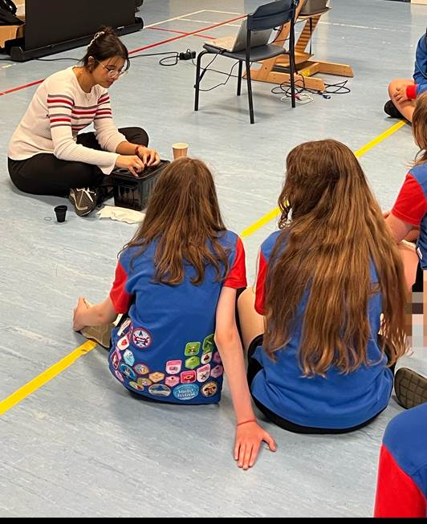
We were also proud to win funding from the Ford C3 competition, thanks to which Seeds for Thought has been able to scale its outreach, develop new educational materials, increase kit production and distribution, and continue to offer all of our education sessions free of charge to schools and community groups. We are proud of the social and commercial progress we have made and remain committed to sustain and grow our impact.
If your organisation would like to host a free session, partner with us, or support our work, please get in touch with us via email: seedsforthoughtsoton@gmail.com

Instagram: @project_seedsforthought
LinkedIn: https://www.linkedin.com/company/seeds-for-thought/

